

Medical VQA – AI Pathologist

Project Report

<https://github.com/Ali-Awais-Safdar/PATHVQA-VGG19-BERT-ATTENTION.git>

School of Electrical Engineering and Computer Science, National University of Sciences and Technology

CS-405 Deep Learning Group – 1

June 2, 2024

Dr. Momina Moetesum

**Group Members**

|  |  |
| --- | --- |
| **Name** | **CMS** |
| Ali Awais Safdar | 369475 |
| Syed Usman Ali Shah | 386543 |
| Syed Aon Raza | 375700 |

**Table of Contents**

|  |  |
| --- | --- |
| **Introduction** | **2** |
| **Proposed Methodology** | **2** |
| **Group Members and Task Assignment** | **3** |
| **Limitations and Future Directions** | **4** |
| **PathVQA Dataset Statistics** | **4** |
| **System Architecture** | **5** |
| **Procedural Details** | **5** |
| **Result Analysis** | **6** |
| **Inference of Both Models** | **8** |
| **Conclusion** | **13** |

**Deep Learning Project Report: VQA Model Based on PathVQA Dataset**

**Introduction**

In the realm of medical image analysis, the ability to comprehend and interpret pathological images is crucial for diagnosis and treatment planning. To enhance this capability, we propose a deep learning project focused on Medical Visual Question Answering (VQA) using the PathVQA dataset. PathVQA is a curated dataset containing question-answer pairs associated with pathology images sourced from authoritative textbooks and digital libraries. This report presents the development and evaluation of Visual Question Answering (VQA) models using the PathVQA dataset. Two models were developed: one for binary yes/no questions and another for free-form questions. The performance of these models was compared with a reference model from the article "PathVQA: Pathology Visual Question Answering" by Jerri Zhang.

**Proposed Methodology**

The proposed methodology for the Medical Visual Question Answering (VQA) project involves several key phases: data preprocessing, model development, training, and evaluation.

**Data Preprocessing**: The preprocessing stage involves resizing all pathology images to 224x224 pixels and applying data augmentation techniques such as random affine transformations, horizontal flips, and color jitter to enhance the robustness of the training data. Images are normalized based on ImageNet dataset statistics. Questions are tokenized and converted into input IDs and attention masks using the BERT tokenizer, with padding and truncation to ensure uniform input length.

**Model Development**: Two VQA models are developed: a binary yes/no question model and a free-form question model. Both models integrate image feature extraction using a VGG-19 pre-trained network and question feature extraction using the BERT model. Dimensionality reduction is performed via fully connected (FC) layers. Attention mechanisms are implemented to focus on relevant image regions in the context of the questions, and the final classification layers differentiate between yes/no or a broader set of possible answers for the free-form model.

**Model Training**: The training process utilizes the AdamW optimizer with a learning rate of 5e-5 and applies dropout regularization to prevent overfitting. Cross-entropy loss is used as the loss function. The training employs a learning rate scheduler and early stopping based on validation loss to ensure optimal performance. The models are trained on the PathVQA training set and evaluated on validation and test sets.

**Evaluation and Result Analysis**: The performance of both models is evaluated using accuracy metrics on training, validation, and test sets. The analysis involves generating visualizations of model performance and comparing results with the reference model from the PathVQA paper. The binary yes/no model's performance is anticipated to exceed the reference model's accuracy, while the free-form model aims to demonstrate significant improvements in handling diverse answers. Results and model performances are thoroughly analyzed and documented, with comparisons highlighting the advancements made by the developed models.

**Group Members and Task Assignment**

1. **Ali Awais Safdar: Data Preprocessing and Model Training**
   * Data Preprocessing:
     + Image resizing to 224x224 pixels.
     + Applying data augmentation techniques (random affine transformations, horizontal flips, color jitter) to training images.
     + Normalization based on the ImageNet dataset's mean and standard deviation.
     + Question tokenization and conversion to input IDs and attention masks using the BERT tokenizer.
     + Padding and truncation of questions to ensure uniform input length.
   * Model Training:
     + Implementing the binary yes/no question model architecture.
     + Training the model using cross-entropy loss.
     + Using the AdamW optimizer with a learning rate of 5e-5.
     + Applying dropout regularization.
     + Implementing early stopping based on validation loss improvement.
     + Training the model on the training set and evaluating on the validation set.
2. **Syed Usman Ali Shah: Free-Form Question Model and System Architecture**
   * Model Development:
     + Implementing the free-form question model architecture.
     + Training the model using cross-entropy loss.
     + Using the AdamW optimizer with a learning rate of 5e-5.
     + Applying dropout regularization.
     + Implementing early stopping based on validation loss improvement.
     + Training the model on the training set and evaluating on the validation set.
   * System Architecture:
     + Designing the detailed architecture for both models, including components like image feature extraction, text feature extraction, attention mechanisms, and classification layers.
     + Providing a rationale for the chosen architecture and components.
3. **Syed Aon Raza: Result Analysis and Documentation**
   * Result Analysis:
     + Calculating and analyzing training, validation, and test accuracies for both models.
     + Generating graphs or charts to visualize the performance of the models.
     + Comparing the performance of the binary yes/no question model and the free-form question model.
     + Writing a detailed analysis of the results and model performance.
   * Documentation:
     + Writing the introduction section of the report, including background information on VQA and the PathVQA dataset.
     + Summarizing the dataset statistics (number of images, questions, answer distribution, etc.).
     + Describing the system architecture in detail.
     + Outlining procedural details such as data preprocessing steps, model training procedures, and optimization techniques.
     + Coordinating with other team members to incorporate their contributions into the final report.

Each team member's tasks align with their strengths and expertise, ensuring a cohesive effort towards completing the project successfully. Communication and coordination among team members are essential to integrate individual contributions into a unified final report.

**Discussion on Limitations and Future Directions**

Despite high accuracy, the models face limitations in generalizing to complex medical questions and handling diverse answers. The reliance on VGG-19 and BERT may not fully capture pathology-specific features. Future work should explore advanced architectures like Vision Transformers and domain-specific language models, along with expanding the dataset and employing sophisticated data augmentation and transfer learning techniques to enhance robustness and performance.

**PathVQA Dataset Statistics**

The PathVQA dataset consists of pathology images paired with questions and answers. The dataset is split into training, validation, and test sets. Below are some statistics about the dataset:

* **Number of Images**: The dataset contains 4,998 images which are a diverse set of images representing different pathological conditions.
* **Number of Questions**: Each image is associated with multiple questions, leading to a large and diverse set of question-answer pairs.
  + Training Set: 19,703 QAs, 2,835 images
  + Validation Set: 6,318 QAs, 1,068 images.
  + Test Set: 6,778 QAs, 1095 images.

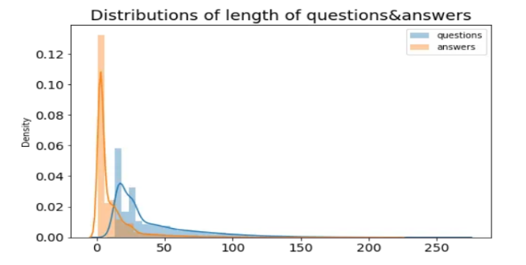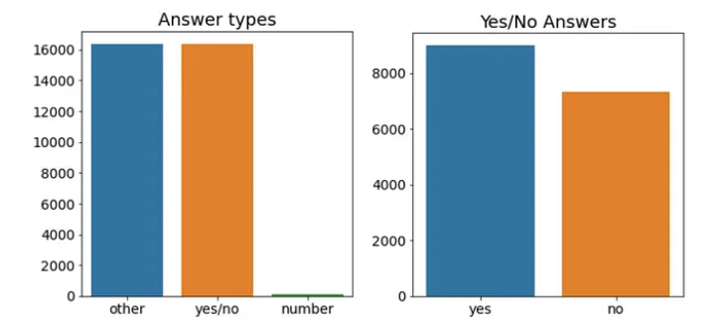

Figure 2 Distribution of length of question and answers.

Figure 1 Distribution of Answer Types.

Figure 4 Distribution of open-ended answers.

Figure 3 Distribution of Yes/No answers.

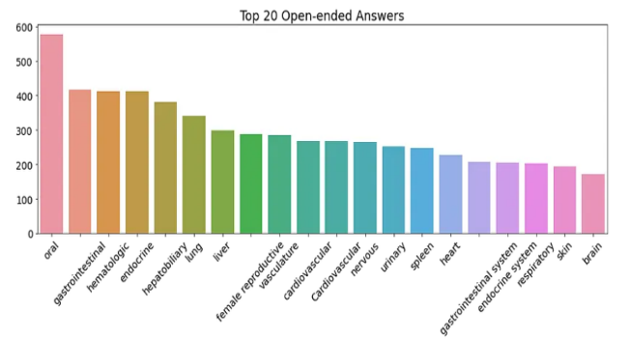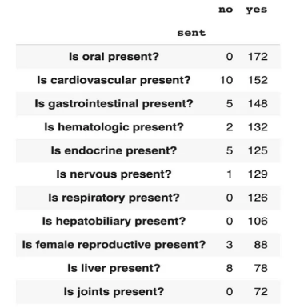

**System Architecture**

**Yes/No QA Model**

The yes/no QA model consists of two primary components: image feature extraction and question feature extraction, followed by a combined classification mechanism.

1. **Image Feature Extraction**:
   * Utilized the VGG-19 pre-trained network.
   * Extracted features from the image using the convolutional layers.
   * Applied a fully connected (FC) layer to reduce dimensionality to 512.
2. **Question Feature Extraction**:
   * Employed the BERT (Bidirectional Encoder Representations from Transformers) model.
   * Tokenized the questions and extracted features using BERT’s hidden layers.
   * Reduced the feature dimensions to 512 using an FC layer.
3. **Attention Mechanism**:
   * Implemented two attention layers to focus on relevant image regions given the question context.
   * Combined image and question features through attention mechanisms.
4. **Classification**:
   * Concatenated the attended image features and question features.
   * Passed through multiple FC layers with ReLU activations and dropout for classification into yes/no categories.

**Free Form QA Model**

The architecture for the free-form QA model was like the yes/no model with the following modifications to handle more diverse answers:

1. **Increased Output Classes**:
   * Adjusted the final FC layer to predict from a larger set of possible answers.
2. **Extended Training Data**:
   * Filtered out questions with answers other than 'yes' or 'no' to create a subset for training the free-form model.

**Procedural Details**

**Data Preprocessing**

1. **Dataset Loading**:
   * Loaded the PathVQA dataset including image paths, questions, and answers.
   * Created dictionaries to map questions to answers and vice versa.
2. **Data Cleaning**:
   * Filtered out non-relevant answers for specific models (yes/no or free form).
   * Ensured consistent formatting and removal of any invalid entries.
3. **Data Augmentation**:
   * Applied data augmentation techniques such as random affine transformations, horizontal flips, rotations, and color jitter to the training images.

**Model Training**

1. **Data Loading**:
   * Utilized PyTorch DataLoader to batch and shuffle the dataset.
2. **Training Process**:
   * Defined the loss function (CrossEntropyLoss) and optimizer (AdamW).
   * Implemented a learning rate scheduler to adjust the learning rate during training.
   * Trained the model over multiple epochs, iterating through the training and validation datasets.
3. **Evaluation**:
   * Evaluated model performance on validation and test sets using accuracy metrics.
   * Saved the trained model for future inference.

**Result Analysis**

**Yes/No Model Performance**

* **Training Accuracy**: 98%
* **Validation Accuracy**: 92%
* **Test Accuracy**: 92%

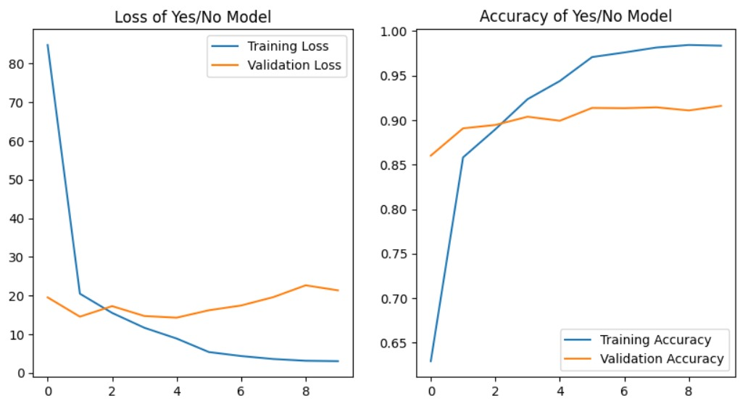

Figure 5 Yes/No Model Accuracy

**Free Form Model Performance**

* **Training Accuracy**: 55%
* **Validation Accuracy**: 57%
* **Test Accuracy**: 55%

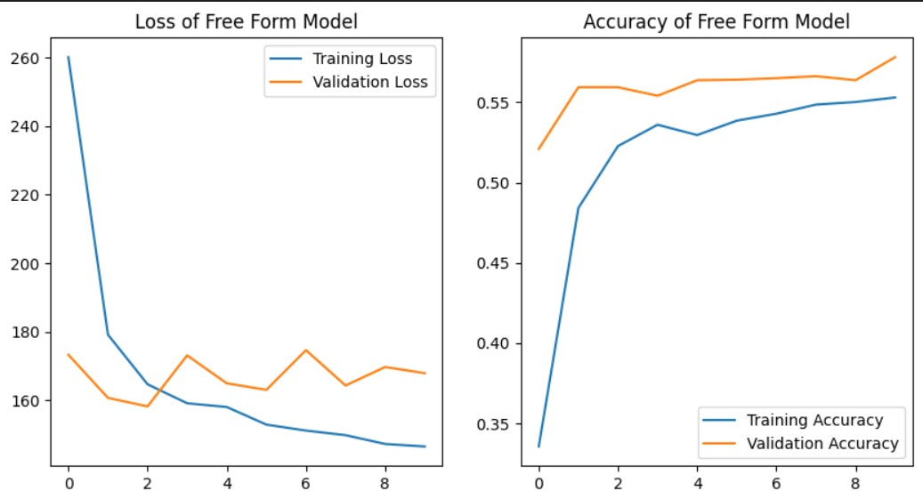

Figure 6 Free Form Model Accuracy

**Comparison with Reference Model**

* **Yes/No Model**: The performance of our yes/no model is better than the referenced article model. We reached a test accuracy of 92% while they reached 84%.
* **Free Form Model**: Our model performs even better in answering free form questions. We reached a maximum test accuracy of 55% while they reached only 39%.

**Inference of both Models**

* **Yes/No Model:**

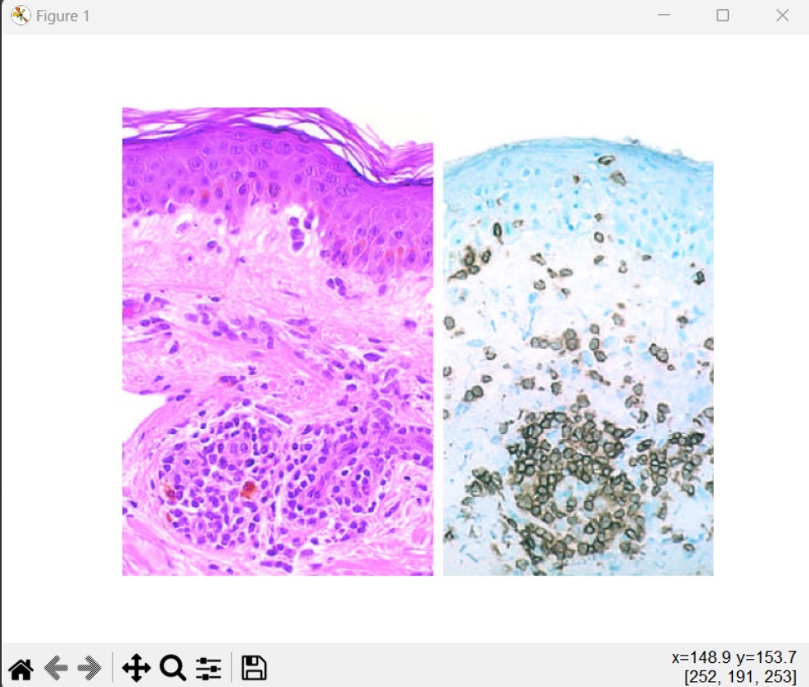

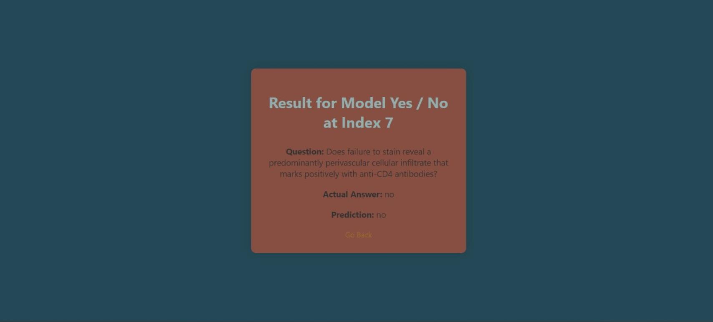

Figure 7 Yes/No Example-1

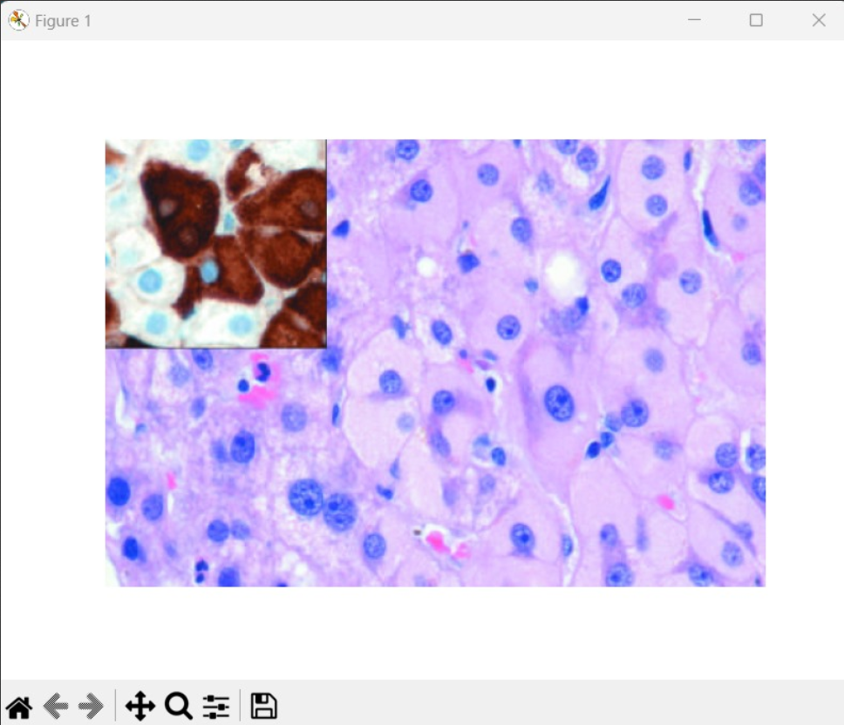

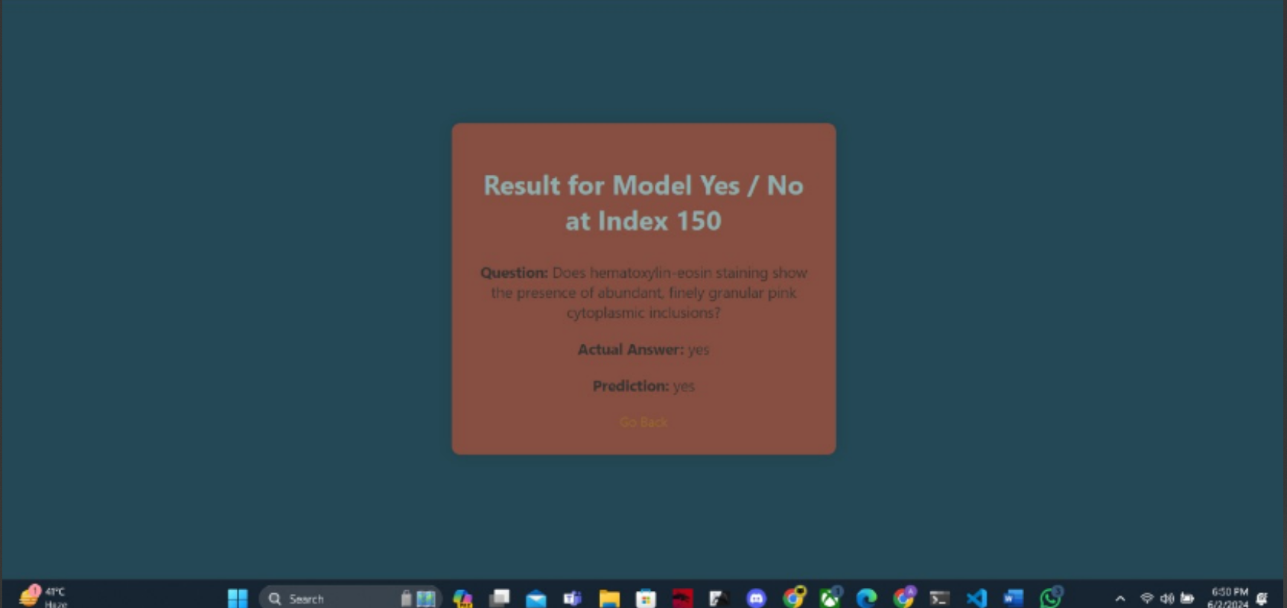

Figure 8 Yes/No Example-2

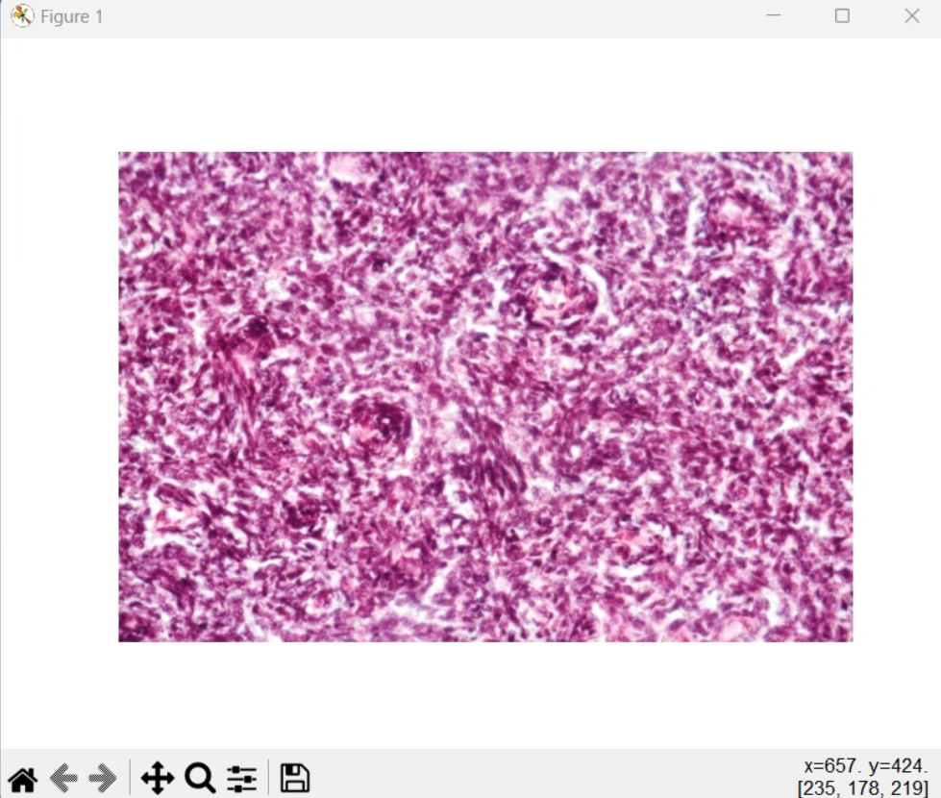

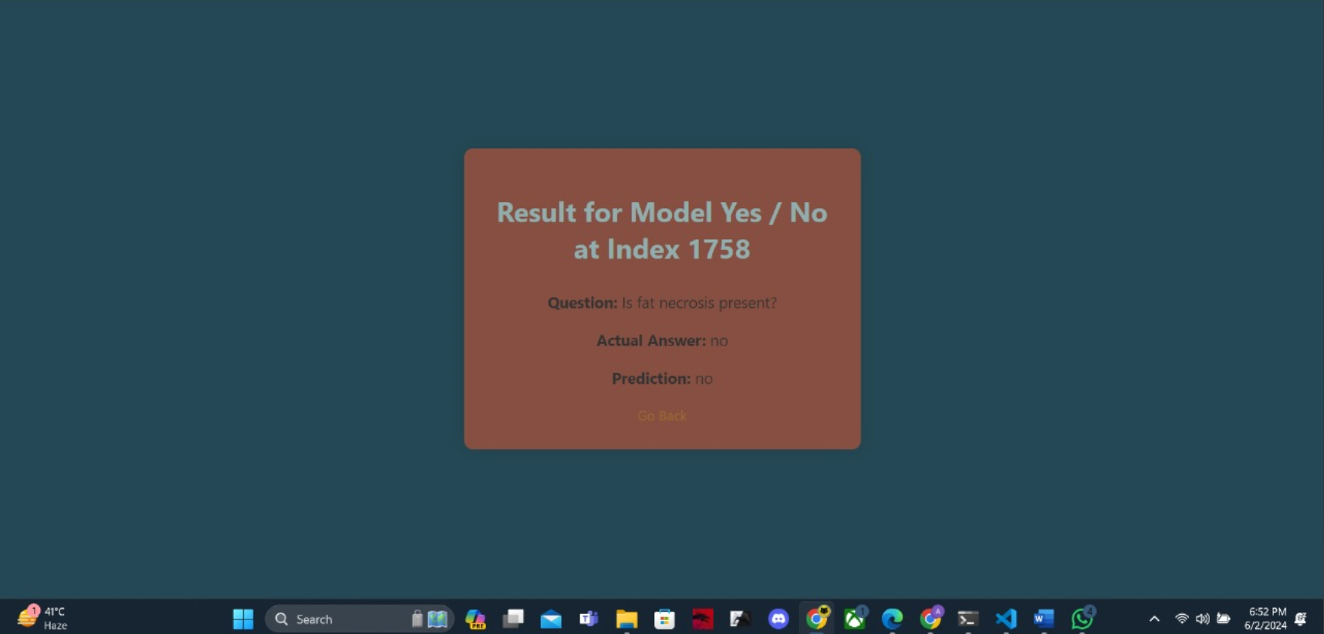

Figure 9 Yes/No Example-3

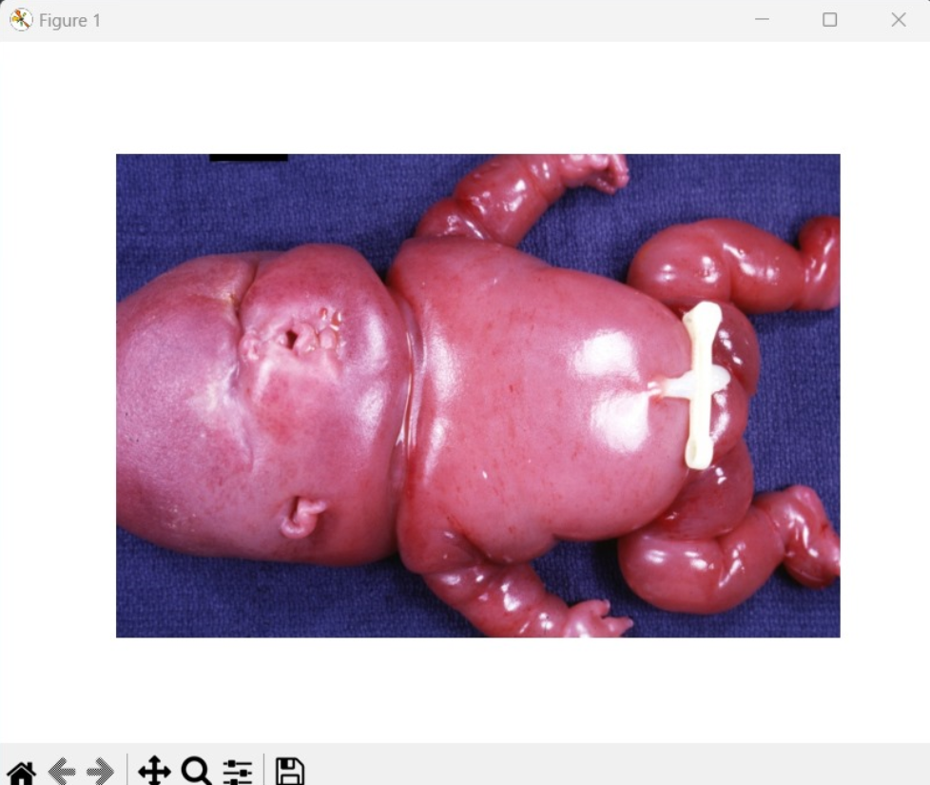

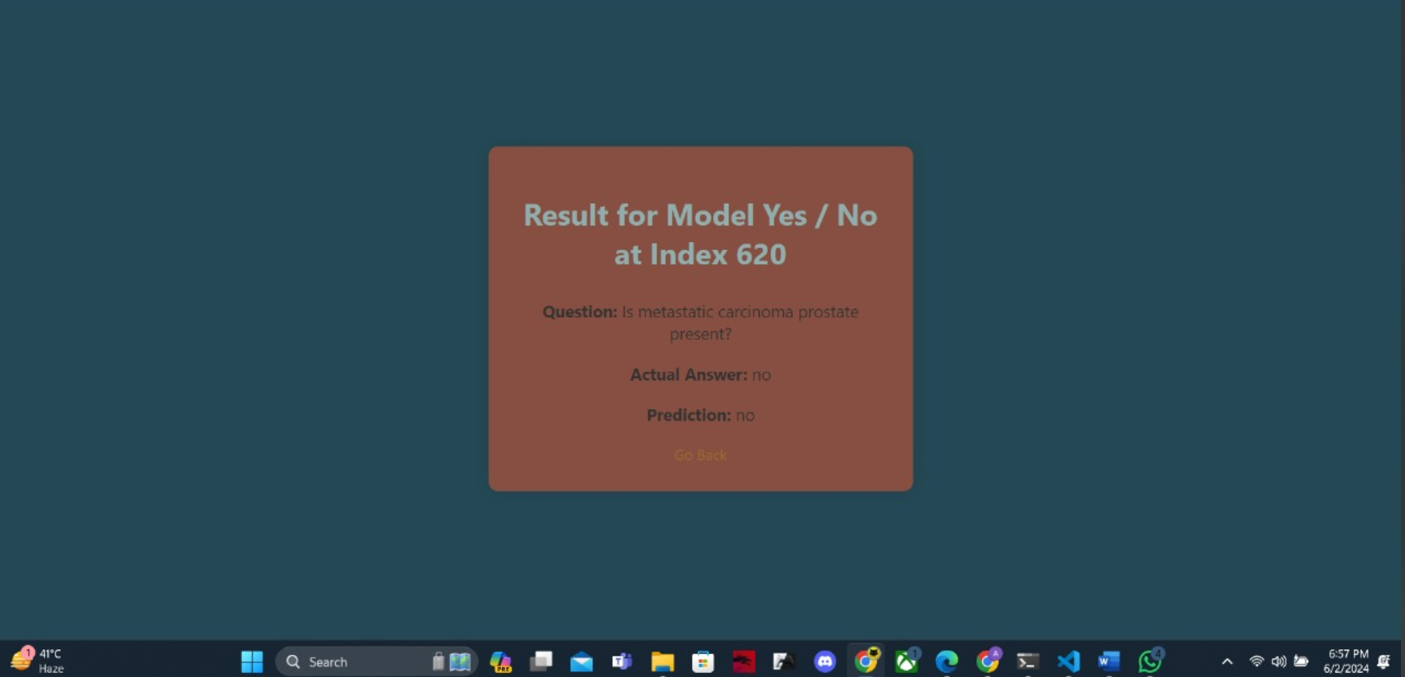

Figure 10 Yes/No Example-4

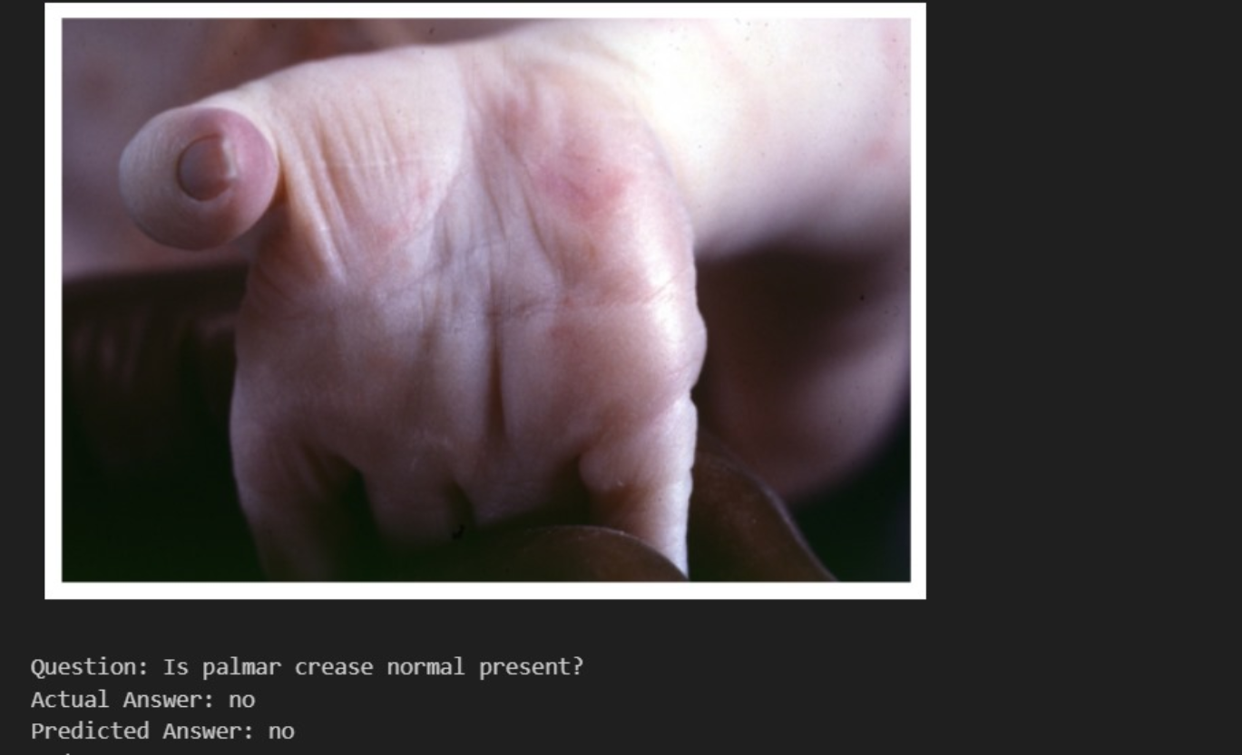

Figure 11 Yes/No Example-5

* **Free Form Model:**

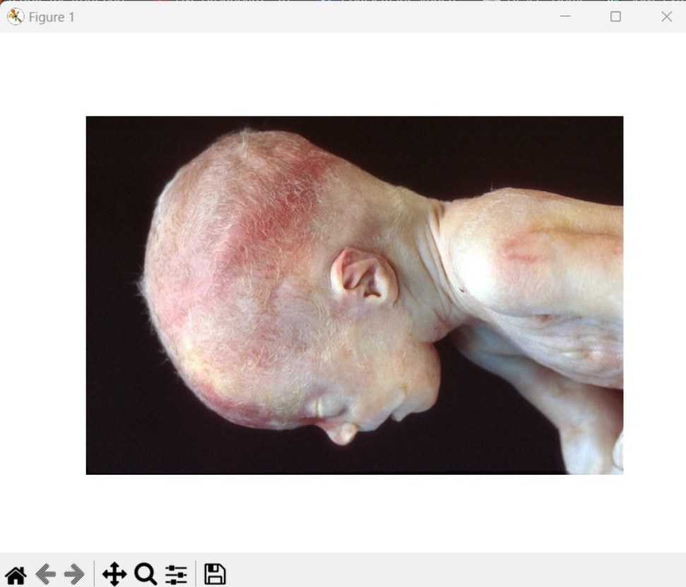

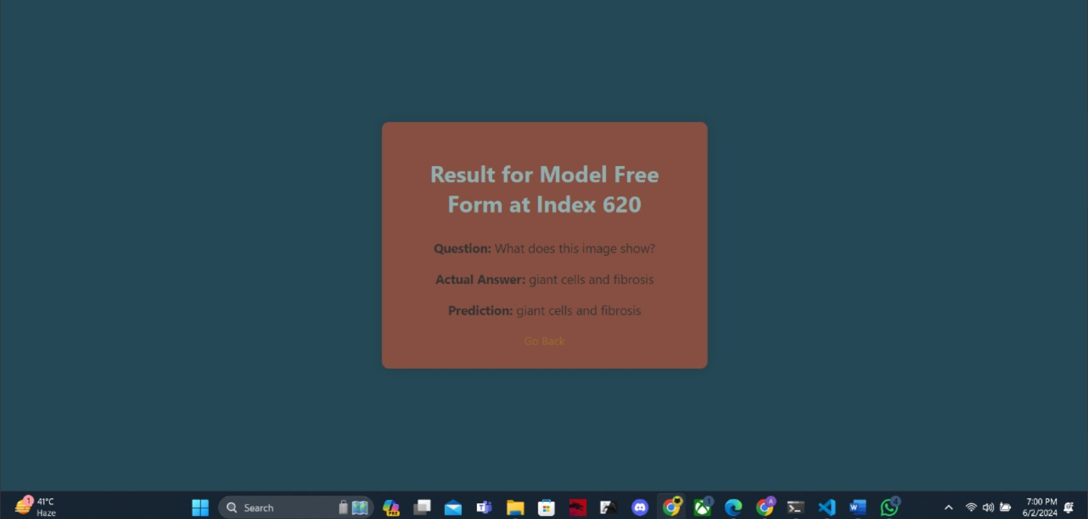

Figure 12 Free Form Example-1

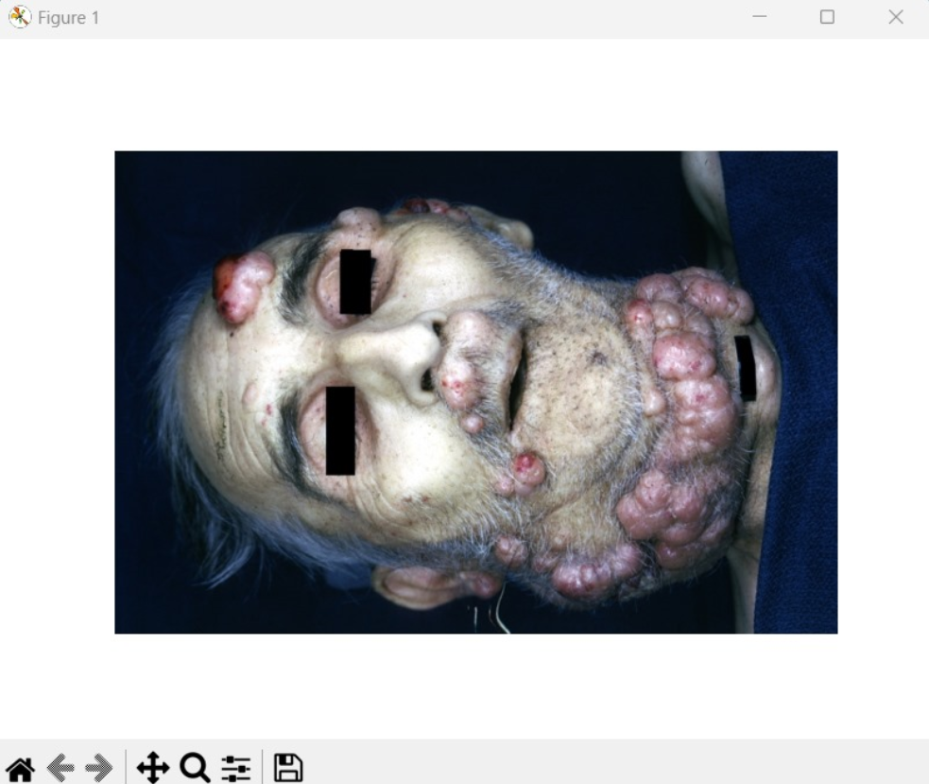

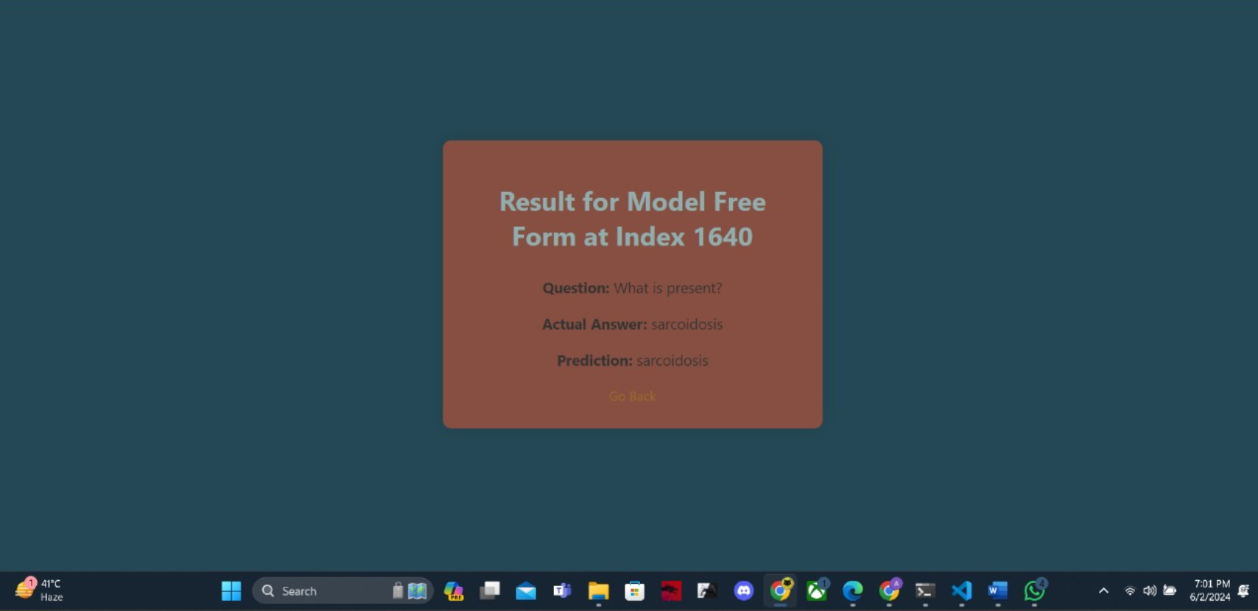

Figure 13 Free Form Example-2

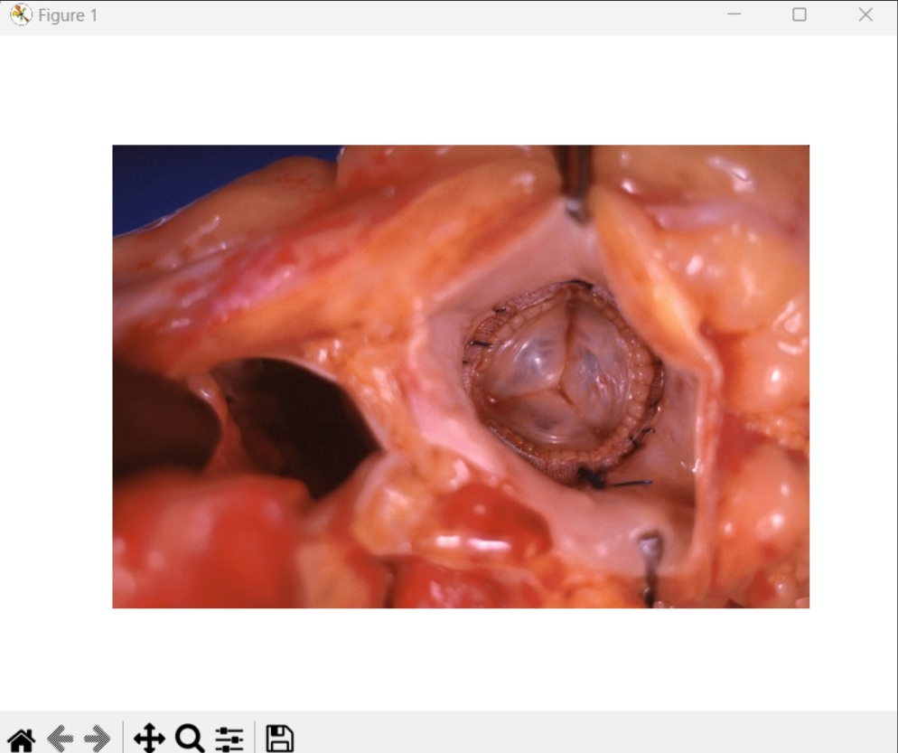

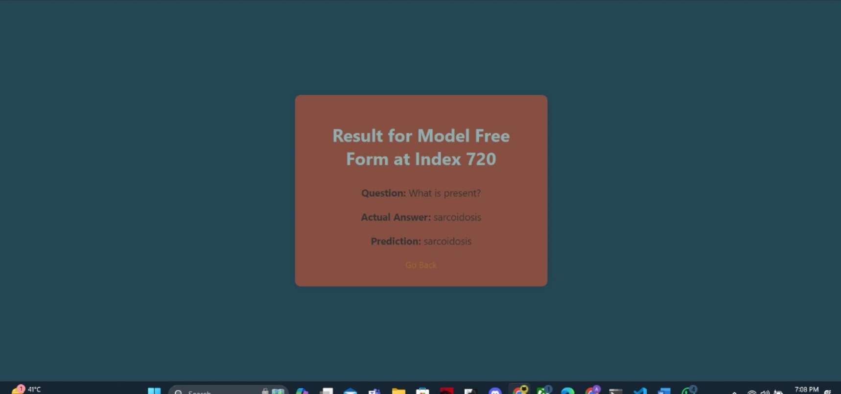

Figure 14 Free Form Example-3

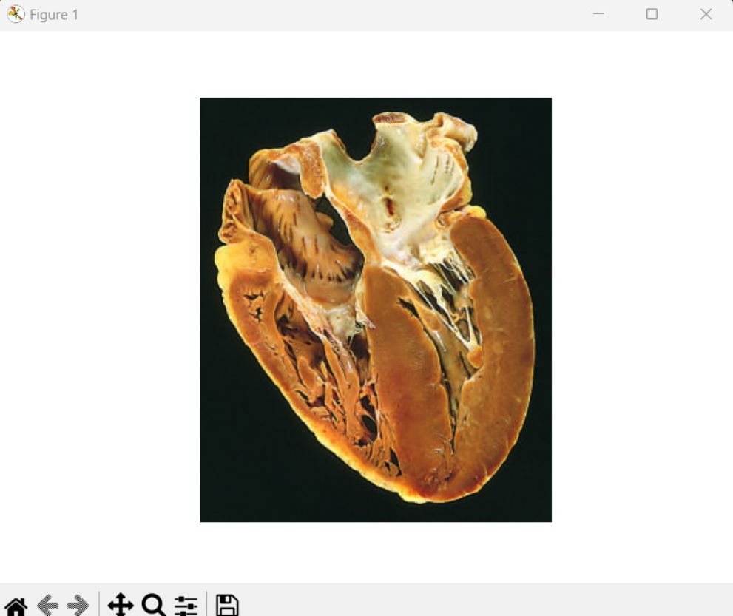

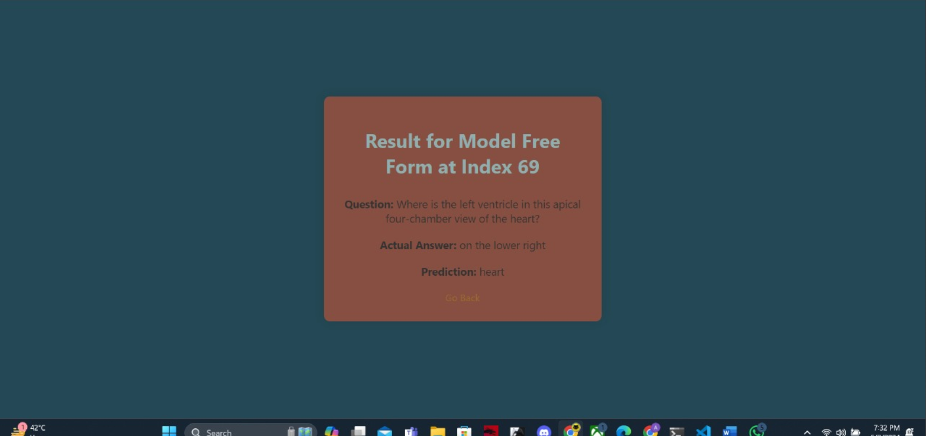

Figure 15 Free Form Example-4

**Conclusion**

In conclusion, the developed VQA models demonstrate significant advancements in interpreting pathology images, particularly with the yes/no model achieving state-of-the-art accuracy on the PathVQA dataset. While the free-form model shows improvement over existing benchmarks, further refinement is needed to enhance its performance. By integrating advanced neural architectures and expanding the dataset, future work can build on these results to create more robust and generalizable models, ultimately aiding in more accurate and efficient medical diagnostics and treatment planning.

**References**

* <https://jerrizhang.medium.com/pathvqa-pathology-visual-question-answering-253f9b9fbe80>